Name:___________________ 10th Grade Honors

Choose ONE of the following texts to independently read. Every week, you should be adding at least 10 journal entries as you read. Remember that this is ACTIVE reading, so you must track your thoughts and observations using the guidelines listed below. You may download this document on your computer and keep your notes digitally. If a digital journal isn’t something that works for you, feel free to use loose-leaf paper folded in half. It is your choice.

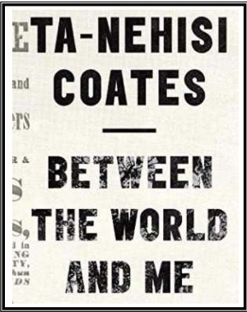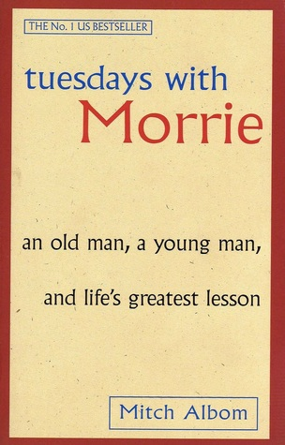

To access your reading, click on the link below depending on the book you choose to read.

Between the World and Me Link: https://www.mercerislandschools.org/cms/lib3/WA01001855/Centricity/Domain/640/Ta-Nehisi%20Coates%20PDF.pdf
Tuesdays with Morrie Link
https://www.stcs.org/view/7786.pdf

DIRECTIONS:

In double-entry journals, facts are written on the left and interpretations or reactions on the right. In the left-hand (fact) column, you may include quotations, summaries, or paraphrases. Facts will often be from the text we’re working on (a novel, poem, critical essay), but facts may also come from class discussions—you may quote something a peer said in class or summarize our day’s discussion. Occasionally, we may also use the left-hand column to pose a question, to which you will respond in the right-hand column. In the right-hand (interpretation and reaction) column, you may analyze or personally respond. Sometimes you will respond twice to the same passage, including an initial reaction and a reaction after reflection (or discussion).
Ideas for right-side entries:
- What is the author’s purpose in writing this text? Give support from the text.
- How does this tie in with my experience, previous readings, class discussions, expectations?
- What do I not understand? What questions do I have?
- Do I agree/disagree with the author? Why?
- What impressed me/annoyed me about the reading?
- What do I notice about the author’s techniques—how does he or she emphasize a point or evoke a reaction? (Consider mood, tone, foreshadowing, irony, figurative language devices, sound devices, and other literary devices. Figurative language devices include simile, metaphor, personification, hyperbole. Sound devices include rhyme, alliteration, assonance, consonance.
- How does this new information fit with my beliefs, my philosophy, prior knowledge?
- Where have my ideas been challenged, changed, confirmed? Reflections should be more than "I like this idea," or "I've never met a person who could live up to this."

Comments should reflect thoughtful views on the implications of what the author is saying. The why should be explored rather than the what. Be sure to title and date each entry, and to leave room for me to respond.

Example of format and expectation from the book 1984 (What I’m reading now.)
Chapter and  Page # | Direct Quote/ Paraphrase | Strategy/ Connection/ Analysis
Ch. 1, pg 5 | “The programs of the Two Minutes Hate varied from day to day, but there was none in which Goldstein was not the principal figure.” | WEAK: Everyone is required to participate in this.  STRONG: Mob-mentality and group-think are essential to sustaining the Party’s control over the people in Oceania. Their tactics extend to the use of a scapegoat, in the form of Goldstein, in order to ensure that their members direct their subconscious feelings away from Oceania and instead direct them to a non-existent external enemy.

DIRECTIONS FOR THIS SPECIFIC DOUBLE ENTRY JOURNAL:

Be sure to have at least 15 of your comments be comparisons and/or connections with society today—family, school, your city, your country, other countries, the world. And at least 10 of your comments should be a rhetorical strategy that is being used. Meaning, you’re analyzing imagery, word choice (diction), metaphors, similes, irony, etc.)

Chapter and  Page # | Direct Quote/ Paraphrase | Strategy/ Connection/ Analysis
Chapter and  Page # | Direct Quote/ Paraphrase | Strategy/ Connection/ Analysis
Chapter and  Page # | Direct Quote/ Paraphrase | Strategy/ Connection/ Analysis
Chapter and  Page # | Direct Quote/ Paraphrase | Strategy/ Connection/ Analysis
Chapter and  Page # | Direct Quote/ Paraphrase | Strategy/ Connection/ Analysis
Chapter and  Page # | Direct Quote/ Paraphrase | Strategy/ Connection/ Analysis
Chapter and  Page # | Direct Quote/ Paraphrase | Strategy/ Connection/ Analysis

POST-READING ACTIVITY:

Once you are done reading, you are to respond to the following questions depending on the book you chose:

If you chose Between the World and Me
- Coates writes, “But you are a black boy, and you must be responsible for your body in a way that other boys cannot know. Indeed you must be responsible for the worst actions of other black bodies, which somehow, will always be assigned to you.”

For your responses reference or paraphrase specific examples from the text.
a) Why do you think he is so intentional in mentioning the word “body”?
b) How does the idea of the black body fit into contemporary conversations about race (e.g., the Black Lives Matter Movement, etc.)?

- In what ways does history, or the media (TV, newspapers, internet, social media, etc.), tell us who or what matters? Who counts and who does not? What are some examples? Find at least three specific quotes to support your response.

If you chose Tuesdays with Morrie

A) Now, describe Mitch’s life choices since he graduated from college. Include specific information/decisions with page numbers. This should come from more than one part of the reading.

B) How is the culture Mitch ‘buys’ different from Morrie’s? Find at least three specific quotes to support your response. Copy the quotes (with page numbers) and explain each one.

Reflection/ Journal Assignment:
Now that you have completed your book, reflect on the message and teachings of the author. This should be at minimum a one and a half page reflection, double spaced (12 pt font, Times New Roman) or hand-written (no skipping lines if hand-written).

Questions to consider:
- What was most surprising, intriguing, or challenging to you about this book?
- What are the next steps for you after reading this book? What would you like to do, read, or learn more about?
- What were some of the differences between this book and the books you typically read?
- What did you learn from this book? What will you take from this book moving forward?
- What questions do you have about the book that you have read?

